

|  |  |
| --- | --- |
| **Modelo** | MEC-D2/50B |

|  |  |  |  |  |  |  |  |  |  |  |
| --- | --- | --- | --- | --- | --- | --- | --- | --- | --- | --- |
| MULTIPLICADOR  Revoluciones/ Relación | MODELO | l/min | 500 | 550 | 600 | 700 | 900 | 900 | 1000 | 1100 |
| m3/hora | 30 | 33 | 36 | 42 | 48 | 54 | 60 | 66 |
| l/seg | 8.3 | 9.2 | 10 | 11.7 | 13.3 | 15 | 16.7 | 18.3 |
| 485/1:8.27  540/1:7.43 | MEC - D 2/50B | **H** | **95** | **95** | **94** | **92** | **89** | **86** | **82** | **77** |
| P | 21.5 | 22 | 23 | 24 | 25.5 | 27 | 28 | 28.5 |

H = Altura de impulsión manométrica total en m.

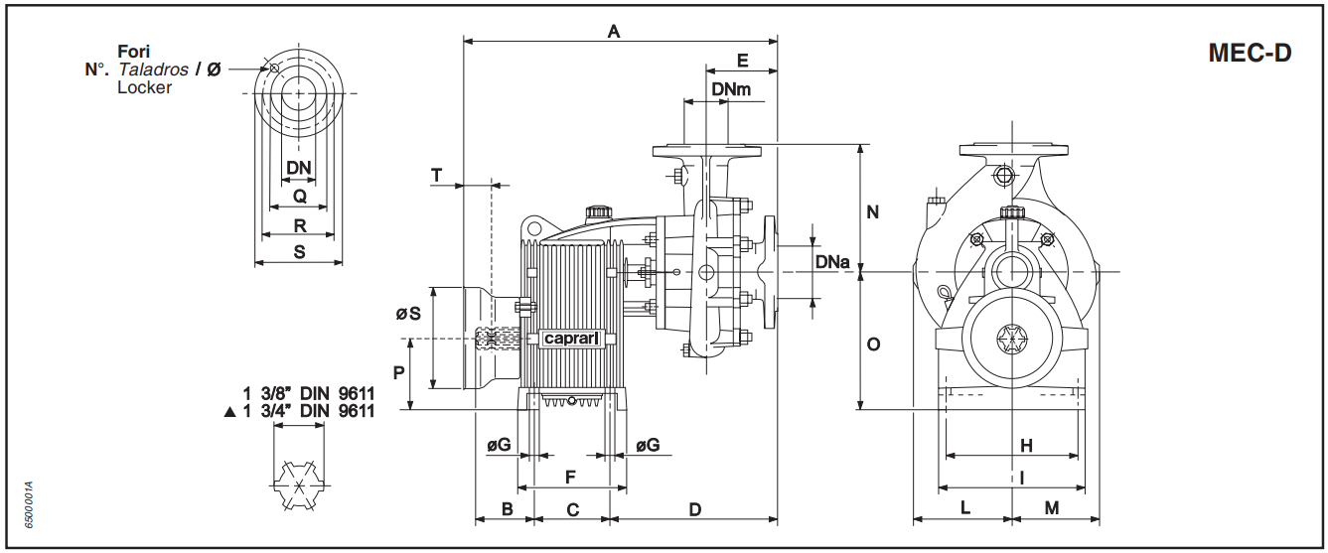P = Potencia absorbida en HP.

|  |  |  |  |  |  |  |  |  |  |  |  |  |  |  |  |  |  |  |  |
| --- | --- | --- | --- | --- | --- | --- | --- | --- | --- | --- | --- | --- | --- | --- | --- | --- | --- | --- | --- |
| **MODELO** | DNa | DNm | A | B | C | D | E | F | G | H | I | L | M | N | O | P | S | T | PESO |
| MEC-D2/50B | 65 | 50 | 550 | 94 | 110 | 255 | 108 | 152 | 14 | 205 | 230 | 150 | 135 | 225 | 217 | 110 | 240 | 128 | 49 |

|  |  |
| --- | --- |
| **BRIDAS** | |
| Ø Boca | 50 |
| Q | 102 |
| R | 125 |
| S | 165 |
| N° Taladro | 4 |
| Ø Taladro | 18 |

|  |  |
| --- | --- |
| **BRIDAS** | |
| Ø Boca | 65 |
| Q | 122 |
| R | 145 |
| S | 185 |
| N° Taladro | 4 |
| Ø Taladro | 18 |

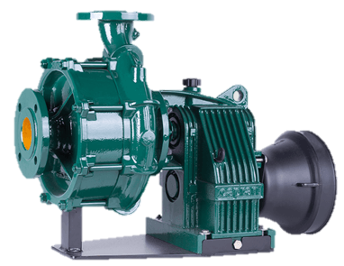

|  |  |
| --- | --- |
| **Potencia nominal del tractor** | |
| kW | 30 ÷ 31 |
| HP | 40 ÷ 42 |